# SSRT Robot 2 Quick Start Instructions

## Installation

It is **essential** to use the latest version of Spectrum Lab (V2.76b2 or later), available from <http://www.qsl.net/dl4yhf/spectra1.html#download>

Unzip ”SSRTRobot2.zip” into a convenient folder and run “SSRT Robot 2.exe” directly. There is no installation necessary. A shortcut is provided and can be moved to your Start menu or another suitable location.

## Spectrum Lab

Some important changes are required to the way Spectrum Lab calculates the waterfall and exports the data for users of older versions of SSRT Robot.

Time integration is now done by Spectrum Lab rather than SSRT Robot. This requires the selection of a larger FFT bin size (*Options/ FFT Settings* menu). *FFT input size (“length”)* is set to its maximum value of 524288 in the example below, giving an integration time of 10.9s with a 48kHz sound card (i.e. 10.9 = 524288 / 48000). *Internal average (#FFTs)* is then set to 5 to give an overall integration time of roughly one minute. This smooths the effects of short term noise.

If a large FFT input size draws too much processor time (likely only on much older PC’s), then there is no problem to choose a smaller value and adjust other settings accordingly.

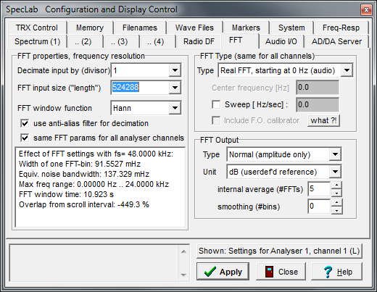

The *Waterfall Scroll Interval* (*Options / Spectrum Display Settings* menu) should be set at around 60 seconds since this is also the interval at which the output data file is written to. Intervals shorter than 60 seconds can be used, but there is usually little practical benefit visible in the final charts (and the output data files will be larger).

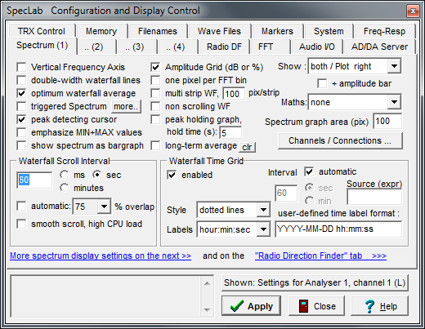

The format of *Export of Calculated Data* (*File/Text file export* menu) has been simplified. Use the example below as a template, noting the new format for the Time column and the inline calculation of spectrum power with the function *avrg(low_freq, hi_freq).* SSRT Robot 2 can display up to 6 separate signals.

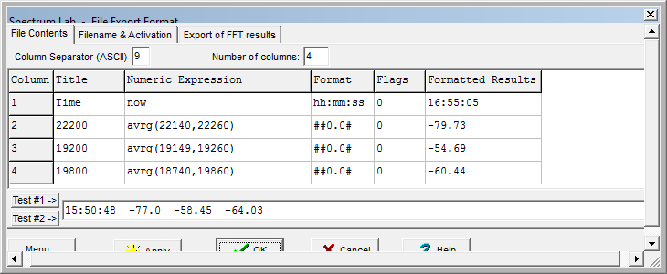

## SSRT Robot 2 input file format

Check that the Spectrum Lab files are in the format expected (example below).

Time 22200 19200 19800

00:00:51 -81.02 -47.3 -55.55

00:01:51 -81.64 -47.66 -55.87

00:02:51 -81.92 -47.71 -55.87

For those wishing to use SSRT Robot 2 with different software, please note the following file format requirements:

* A new data file should be be produced each day, starting at 00:00 midnight local time
* The data files must all stored in a single directory
* The files are plain text ASCII
* The name of each file must be YYYY-MM-DD.txt (e.g. 2010-08-30.txt)
* The first line of each file is always ignored by SSRT Robot 2 (Spectrum Lab writes the column headings here)
* Each subsequent line of the file contains a reading from the radio telescope
* The first column is time of the reading in 24 hour clock format HH:MM:SS
* Subsequent columns contain the power levels of VLF frequencies being monitored
* Power levels can be positive or negative to arbitrary decimal places
* The decimal separator is the full stop character
* The separator character between columns is the TAB character (ASCII 9)
* SSRT Robot 2 can read up to six different signals (i.e. seven columns in total, including the time)
* A reading interval of about one minute is likely to give good results

## SSRT Robot 2 setup

Note the important settings below

*Local disk settings*

Define the folder where the Spectrum Lab output data files are stored, and the root folder where SSRT Robot will store the charts it creates

*Signal settings*

Activate as many columns as you have exported data and want to chart. The *offset* value is optional and will be added to the data before plotting

*SSRT network settings*

*Activate SSRT online reporting* if you will be providing your data for the SSRT online network (separate registration is required. Contact [percival.andrews@gmail.com](mailto:percival.andrews@gmail.com) with details of the stations that you are monitoring and an example daily chart)

*SSRT station name*, etc. All these values will be provided in your registration e-mail. They are case sensitive and need to be entered exactly as given. (A naming scheme has been chosen were the stations in the SSRT online network are each named after notable asteroids to help consistency of presentation. An optional local station title can be chosen as well – see below)

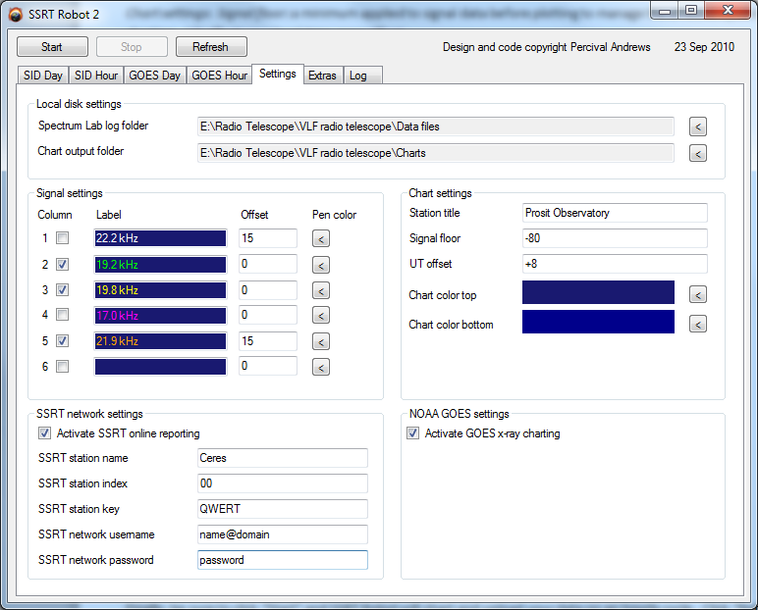

*NOAA GOES settings*

SSRT Robot has the ability to generate Solar X-ray charts to assist with the validation of possible SIDs, using NOAA GOES satellite data downloaded from the internet. Uncheck if your PC is not connected to the internet.

*Chart settings*

*Station title* is a heading chosen for the charts (optional if an *SSRT station name* is also being used, otherwise mandatory)

*Signal floor*: a minimum applied to signal data before plotting to manage the effect dropouts on the charting

*UT offset*: (removed in latest version – now calculated automatically)

## SSRT Robot 2 operations

Click “Start” and SSRT Robot will chart (and upload) your data on an hourly cycle

Click “Refresh” to see the latest data at any time.

Click “Process SID files” to re-process data files in a prior date range (SID Day graphs only)

Click “Upload Log File” to upload an optional text file to the SSRT online network. This is a free-form text file where you can share maintenance or other information as desired. It will be available as a link from your station page online.

